Iyatsiba Lab:
APES // 2026

a hub for creative cross-over
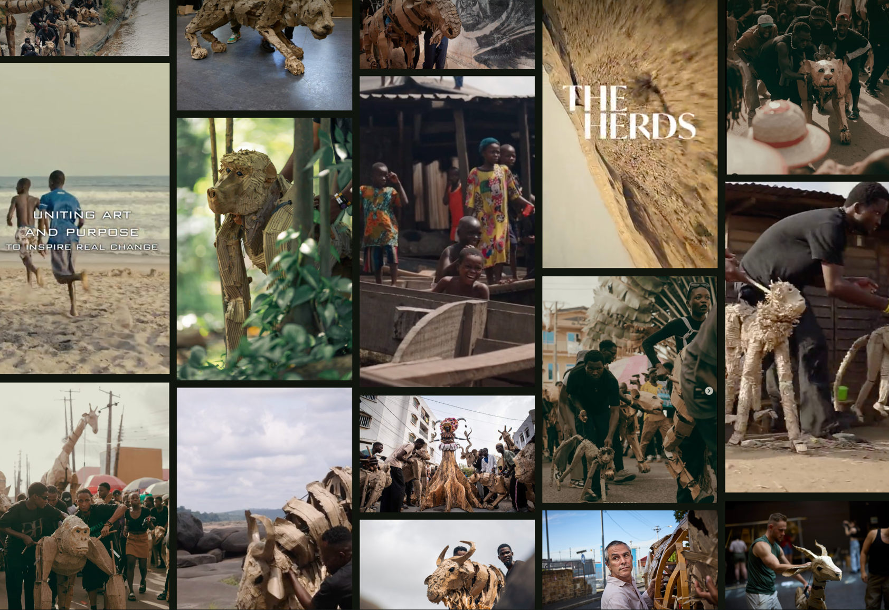

A talk by Premesh Lalu

TUESDAY 24th FEBRUARY 2026 - 17:30 - 20:00
IYATSIBA LAB, UWC

Greatmore Street, Woodstock

You are invited to attend an APES+ talk titled “Iyatsiba Lab: a hub for creative cross-over”, by Prof. Premesh Lalu

With the launch of the Centre for Humanities Research Iyatsiba Lab in Greatmore Street Woodstock, the University of the Western Cape challenges us to reimagine the relationship between the university and the city.

Home to the world renowned Ukwanda Puppetry and Design Art Collective, and programmes in documentary film and sound studies, the Iyatsiba Lab places an arts inquiry in a proximate relationship to postgraduate and doctoral research of the CHR.

As the name "Iyatsiba" attests, the lab enables the surprises that lie in await when knowledge is allowed to leap from one field to another, and nurtures the potential to transform the city through a movement in thought.

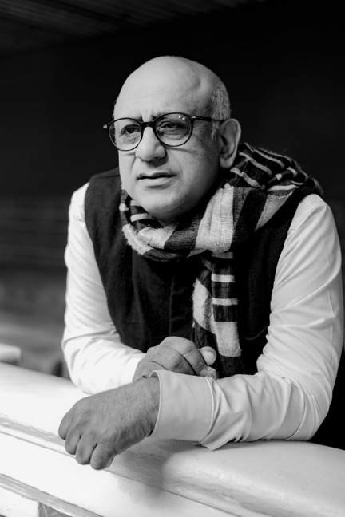
Premesh Lalu
Professor and UK-SA (British Academy/NRF) Chair in Culture and Technics at the Centre for Humanities Research (CHR) at the University of the Western Cape (UWC), South Africa

Lalu is the former director of the CHR and convenor of the Flagship on Critical Thought in African Humanities.

He is the author of The Deaths of Hintsa: Post apartheid South Africa and the Shape of Recurring Pasts (2009), and Undoing Apartheid (Cambridge: Polity Press, 2022).

APES // 2026

RSVP to

info@apes-ct.co.za
by Friday 20th February 2026

APES+ Members free; Guest R100;
Students free on presenting a student card.

Guest bookings kindly attach proof of payment to RSVP: Nedbank Branch: Cape Town – 10 0909
Account #: 1009 724 185

