New Archival Visions at UWC Research Grants and Fellowships (2024)

Through the generous support of the Department of Higher Education and Training (DHET), the Centre for Humanities Research (CHR) at the University of the Western Cape (UWC) offers a range of research grants and fellowships in 2022-2025 to support new research activity in the UWC archives. They form part of the university’s initiative to activate its archival holdings. These include the UWC-Robben Island Museum-Mayibuye Archives and other specialised research, activist, multi- media and art collections at the university that are associated with liberation struggle histories and multiple forms of activism and art production in southern Africa. This archival initiative now invites diverse engagements with the histories, objects, and media in these collections, with eventual outcomes as research theses, papers and/or publications, as well as performances, films and curated works. Awardees will become fellows of the CHR. Information about collections can be found at https://mayibuyearchives.org/ or through email inquiry to vlayne@uwc.ac.za.
The fellowship categories for 2024 include Student Curatorial Fellowships and Postdoctoral Fellowships. Applications should be addressed to the New Archival Visions fellowship selection committee, which is composed of representatives from the New Archival Visions research project, the CHR, and the Faculty of Arts and Humanities at UWC. Decisions of the committee are final. In certain circumstances, the committee may elect to interview suitable candidates.

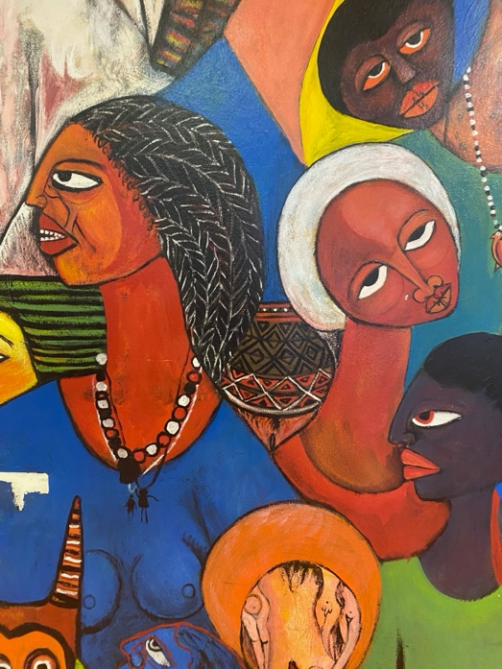

FELLOWSHIPS

Student Curatorial Fellowships
Up to five Student Curatorial Fellowships are available to third-year undergraduate and all postgraduate students. These should facilitate and extend existing degree or project work. Where appropriate, community projects by UWC graduates and alumni may also be considered. We invite candidates to submit application letters that should describe their existing project, and that address one or more specific collections, themes or organisations that form part of the UWC archives. Applicants should motivate why their research is relevant, and how it has the potential to increase or impact on existing knowledge. The application should include the name and contact details of a thesis supervisor, project director or other appropriate person, who is willing to endorse the application with a reference letter.

The application letter must therefore include the following components:
  - outline of existing project
  - collection to be researched
  - motivation
  - research schedule and budget
  - name and contact details of the referee.

Proposals can be located either in a specific discipline and department, or within interdisciplinary studies, and are not confined to any specific degree programme.
Terms of award: upon notice of award and acceptance by the candidate, half of the full allocated grant amount of R20 000 will be made available, with the remainder to be paid upon completion of the project and/or the submission of a final report. The full amount can be awarded upfront in exceptional cases. These reports will feed back into the UWC archives, with the necessary permissions.
Successful candidates will also be invited to participate in different activities around the New Archival Visions programme at the Centre for Humanities Research and present their work in this forum.
Application dates for 2024 awards: applications can be submitted no later than 30 March 2024. Projects should be completed in the 2024 academic year. Applications should be addressed to the New Archival Visions fellowship selection committee, care of Dr Valmont Layne at vlayne@uwc.ac.za.

Postdoctoral Fellowships
Two Postdoctoral Fellowships will be made available in 2024, awarded for one year and renewable for a second year based on satisfactory progress and available funds. These are intended to either initiate original new research in the UWC archives, or to extend existing degree or project work.
Qualified candidates (who have graduated with a PhD no more than five years previously) are invited to submit application letters that should describe their proposed research. The research should address one or more specific collections, themes or organisations that form part of the UWC archives.
Applicants should motivate why their research is important and breaks new ground. The application should include the names and contact details of three referees.
The application must therefore include the following components:

  - description of proposed project
  - collection to be researched
  - motivation
  - research schedule and budget
  - curriculum vitae
  - names and contact details of three referees.

Proposals can be located either in a specific discipline and department, or within interdisciplinary studies, and may be oriented towards creative or curatorial outputs.
Terms of award: once the award has been offered to a successful candidate, this should be accepted in writing. The exact starting date may be negotiated. The fellowship carries a residence requirement, unless there are exceptional circumstances. Successful candidates will also be invited to participate in different activities around the New Archival Visions programme at the Centre for Humanities Research, and to present their work in this forum. Postdoctoral Fellows will submit Annual Progress Reports, and are required to produce two accredited outputs per year, properly attributed to the programme and UWC. These outputs must be published within one year of the completion of the fellowship
Application dates for 2024 awards: applications are due by 30 March 2024. Applications should be addressed to the New Archival Visions fellowship selection committee, care of Dr Valmont Layne at vlayne@uwc.ac.za.

